[7 Segment Display](https://circuitdigest.com/microcontroller-projects/7-segment-display-interfacing-with-arduino)

In this tutorial we are going to interface a seven segment display to Arduino UNO. The display counts from 0-9 and resets itself to zero. Before going further, let us first discuss about seven segment displays.

A seven segment display got its name from the very fact that it got seven illuminating segments. Each of these segments has a LED (Light Emitting Diode), hence the lighting. The LEDs are so fabricated that lighting of each LED is contained to its own segment. The important thing to notice here that the LEDs in any seven segment display are arranged in common anode mode (common positive) or common cathode mode (common negative).

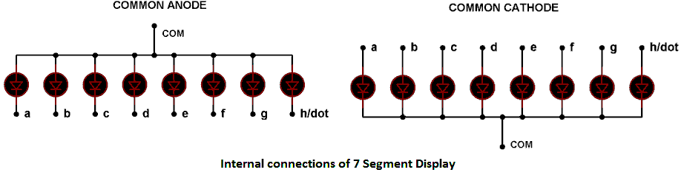

The circuit connection of LEDs in common cathode and common anode is shown in above figure. Here one can observe that, in CC the negative terminals of every LED is connected together and brought out as GND. In CA the positive of every LED is connected together and brought out as VCC. These CC and CA come in very handy while multiplexing several cells together.

Hardware Required

* Arduino UNO Board
* Seven segment display
* hook-up wires

Circuit

The connections which are done for 7 segment display are given below (LED Common Anode):

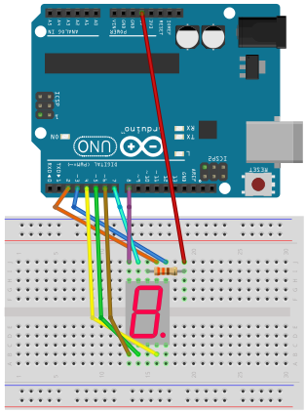

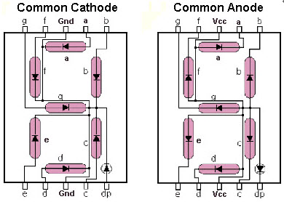

Here we are going to write a program turning each segment ON and OFF for a count 0-9. The working of 0-9 counter is best explained step by step in C code given below:

Code // (for COMMON ANODE)

*In the case of Common Cathode, we connect the resistor 330 Ohm to GND, the source code below will invert the values: HIGH -> LOW, and LOW -> HIGH.*

#define segA 2//connecting segment A to PIN2

#define segB 3// connecting segment B to PIN3

#define segC 4// connecting segment C to PIN4

#define segD 5// connecting segment D to PIN5

#define segE 6// connecting segment E to PIN6

#define segF 7// connecting segment F to PIN7

#define segG 8// connecting segment G to PIN8

// VCC conect to 5V through a resistor 330 Ohm

int COUNT=0;//count integer for 0-9 increment

void **setup**()

{

for (int i=2;i<9;i++)

{

pinMode(i, OUTPUT);// taking all pins from 2-8 as output

}

}

void **loop**()

{

switch (COUNT)

{

case 0://when count value is zero show”0” on disp

digitalWrite(segA, LOW);

digitalWrite(segB, LOW);

digitalWrite(segC, LOW);

digitalWrite(segD, LOW);

digitalWrite(segE, LOW);

digitalWrite(segF, LOW);

digitalWrite(segG, HIGH);

break;

case 1:// when count value is 1 show”1” on disp

digitalWrite(segA, HIGH);

digitalWrite(segB, LOW);

digitalWrite(segC, LOW);

digitalWrite(segD, HIGH);

digitalWrite(segE, HIGH);

digitalWrite(segF, HIGH);

digitalWrite(segG, HIGH);

break;

case 2:// when count value is 2 show”2” on disp

digitalWrite(segA, LOW);

digitalWrite(segB, LOW);

digitalWrite(segC, HIGH);

digitalWrite(segD, LOW);

digitalWrite(segE, LOW);

digitalWrite(segF, HIGH);

digitalWrite(segG, LOW);

break;

case 3:// when count value is 3 show”3” on disp

digitalWrite(segA, LOW);

digitalWrite(segB, LOW);

digitalWrite(segC, LOW);

digitalWrite(segD, LOW);

digitalWrite(segE, HIGH);

digitalWrite(segF, HIGH);

digitalWrite(segG, LOW);

break;

case 4:// when count value is 4 show”4” on disp

digitalWrite(segA, HIGH);

digitalWrite(segB, LOW);

digitalWrite(segC, LOW);

digitalWrite(segD, HIGH);

digitalWrite(segE, HIGH);

digitalWrite(segF, LOW);

digitalWrite(segG, LOW);

break;

case 5:// when count value is 5 show”5” on disp

digitalWrite(segA, LOW);

digitalWrite(segB, HIGH);

digitalWrite(segC, LOW);

digitalWrite(segD, LOW);

digitalWrite(segE, HIGH);

digitalWrite(segF, LOW);

digitalWrite(segG, LOW);

break;

case 6:// when count value is 6 show”6” on disp

digitalWrite(segA, LOW);

digitalWrite(segB, HIGH);

digitalWrite(segC, LOW);

digitalWrite(segD, LOW);

digitalWrite(segE, LOW);

digitalWrite(segF, LOW);

digitalWrite(segG, LOW);

break;

case 7:// when count value is 7 show”7” on disp

digitalWrite(segA, LOW);

digitalWrite(segB, LOW);

digitalWrite(segC, LOW);

digitalWrite(segD, HIGH);

digitalWrite(segE, HIGH);

digitalWrite(segF, HIGH);

digitalWrite(segG, HIGH);

break;

case 8:// when count value is 8 show”8” on disp

digitalWrite(segA, LOW);

digitalWrite(segB, LOW);

digitalWrite(segC, LOW);

digitalWrite(segD, LOW);

digitalWrite(segE, LOW);

digitalWrite(segF, LOW);

digitalWrite(segG, LOW);

break;

case 9:// when count value is 9 show”9” on disp

digitalWrite(segA, LOW);

digitalWrite(segB, LOW);

digitalWrite(segC, LOW);

digitalWrite(segD, LOW);

digitalWrite(segE, HIGH);

digitalWrite(segF, LOW);

digitalWrite(segG, LOW);

break;

break;

}

if (COUNT<10)

{

COUNT++;

delay(1000);///increment count integer for every second

}

if (COUNT==10)

{

COUNT=0;// if count integer value is equal to 10, reset it to zero.

delay(1000);

}

}